APSAR2013: Abstract Template

#First Author ¹, Second Author ²
¹ First Department, First University
First Address, First email
² Second Department, Second University
Second Address, Second email

1. Introduction

This document includes formatting instructions for authors preparing an abstract manuscript for APSAR2013. The authors must follow the instructions given in this document. Entire document should be in Times New Roman Font with single space.

2. Title and Author Details

Title is in 20 pt bold. Author names should be in 12 pts and the affiliation in 11 pts. Put a hash (#) before the corresponding author (e-mail is compulsory for the corresponding author).

3. Headings, Sub-headings

Headings must be in 14 pt bold. There must be a line gap before and after main headings.
3.1 Example of a Sub-heading
Sub-headings must be in 12 pt bold. Also there is a 6 pt space before the sub-heading.

4. Paper Layout

The manuscripts must be prepared using A4 paper settings, with margins as follows:
- Top = 25mm
- Bottom = 25mm
- Left = Right = 25mm
The document should be in one column format. The body text must be in 11 pt regular. Number citations consecutively in square brackets, like so [1]. The acknowledgement and reference sections should not be numbered. Don't use page numbers. Paper is limited to two (2) pages.

5. Figures and Tables

Figure captions must be placed below the figures, as shown in Fig. 1. Tables should have caption with the table number before the table, as shown in Table 1. Figure and Table captions are in 11 pt regular.

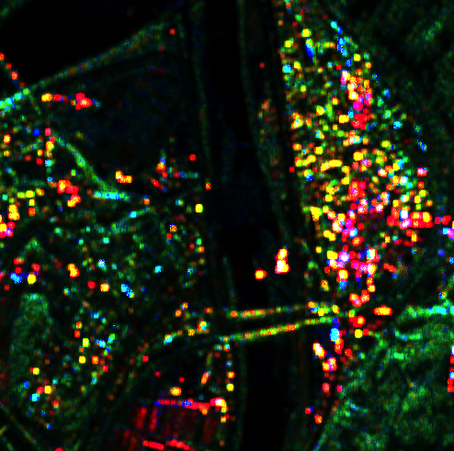

Figure 1: RGB composite image of Pi-SAR image data. Red: Pd, Green: Pv, Bluse: Ps

Table 1: Font Sizes for Papers
Font Size | Appearance
Font Size | Regular | Bold
11 | Body texts,  equations,  Author Addresses, Figure captions, Table captions | Sub-sub-headings
8 | subscripts, superscripts
12 | Author names | Sub-headings
14 |  | Headings
20 |  | Title

References

[1] A. Author, B. Author, “Title of the paper”, Journal Name, vol. XX, No. NN, pp. 000-999, Year.
[2] A. Author, B. Author, C. Author, Book Name, N-th edition, Publisher, Place, pp.000-999, Year.
[3] A. Author, B. Author, C. Author, D. Author, “Title of paper with only first word capitalized,” Proc. Conference Name, Where, Vol. VV, pp. 000-999, Year.

